Franklin COMP 294

Practicum Project Weekly Status Report

Name: Christa Fox

Course Number: COMP294-R1WW (F17)

Project Name: F17Gradebook

Week Number: 5

Progress for the week

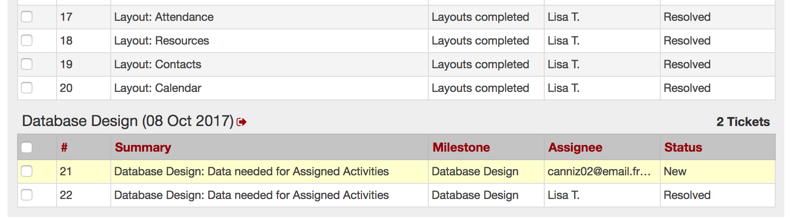

* Completed Ticket 17: Attendance Layout  
  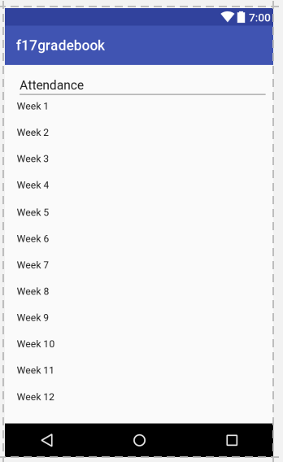
  + The number of weeks will be requested from the student to store in the database.
  + There will be a function that multiplies these weeks by .2, and this number of allowable absences will also be stored in the database.
  + These will allow the user to check the box if that week class was attending and this will be stored to the database as well.
* Completed Ticket 18: Resources Layout  
  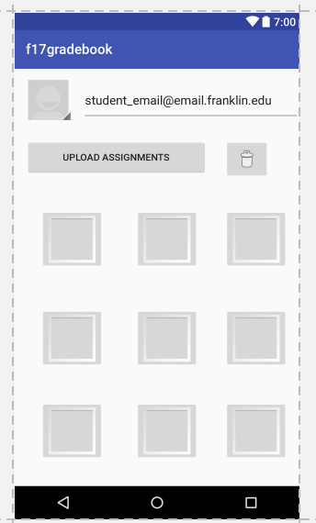
  + By default the students email will show at the top of the screen
  + Optional photo and documents to upload
  + To delete thumbnails will be dragged to the trash.
  + Clicking on thumbnails will advance to the full render.
* Completed Ticket 19: Contacts Layout   
    
  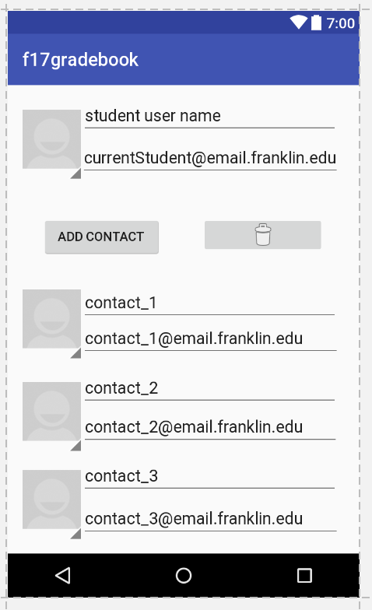
  + The users email will display by default
  + Optionally additional contacts can be added
  + Dragging the contact icon to the trash will delete the user
* Completed Ticket 20: Calendar Layout  
    
  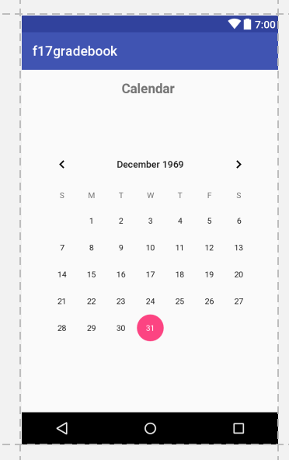
  + Arrows will click to the next or previous month
  + Clicking on a day allows you to view/delete/add events for that day.
* Completed Ticket 22: Database Request  
  

Problems Solved

* Learned android developer.

Communication

* Unfuddle: closed 5 tickets with comments and images
* Pulled from the repository
* Committed changes
* Used text/email
* Google hangout messages and meet October 7, 2017

Goals for next week

* After database is set up by lisa, she will create tickets for fully functional pages in the application.